**Homework-3**

**Question 1:** For the Confusion Matrix shown below, compute the following values:

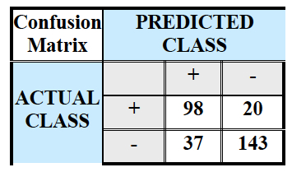

* Precision
* Recall
* F-measure
* Sensitivity
* Specificity

**Answer:**

|  |  |  |  |  |
| --- | --- | --- | --- | --- |
| Confusion Matrix | Predicted Class | | | Total |
| Actual Class |  | + | - |
| + | TP = 98 | TN = 20 | 118 |
| - | FP = 37 | FN = 143 | 180 |
| Total | | 135 | 163 |

For the given confusion matrix, we have values as follows:

True positive (TP) = 98

False Negative (FN) = 20

False Positive (FP) = 37

True Negative (TN) = 143

Actual Yes = 118

Actual No = 180

Predicted Yes = 135

Predicted No = 163

* Precision (p) = $\frac{TP}{TP+FP}$ = 98 / (37+98) = 0.7259
* Recall (r) = $\frac{TP}{TP+FN}$ = 98 / (20+98) = 0.8305
* F-measure (F) = $\frac{2*r*p}{r+p}$ = (2*0.7259*0.8305) / (0.7259+0.8305) = (1.2035) / (1.555) = 0.7739
* Sensitivity (TPR) = $\frac{TP}{TP+FN}$ = 98 / (20+98) = 0.8305

Also, FNR= 1- TPR = 0.1695

* Specificity (TNR) = $\frac{TN}{TN+FP}$ = 0.7944

Also, FPR = 1 – TNR = 0.2056